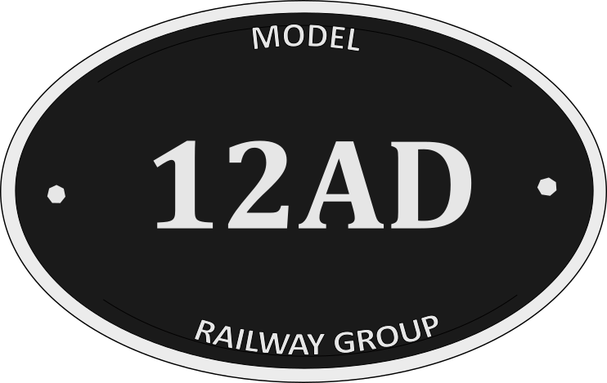

Jacks Hill Loading Point 3
By Michael Johnston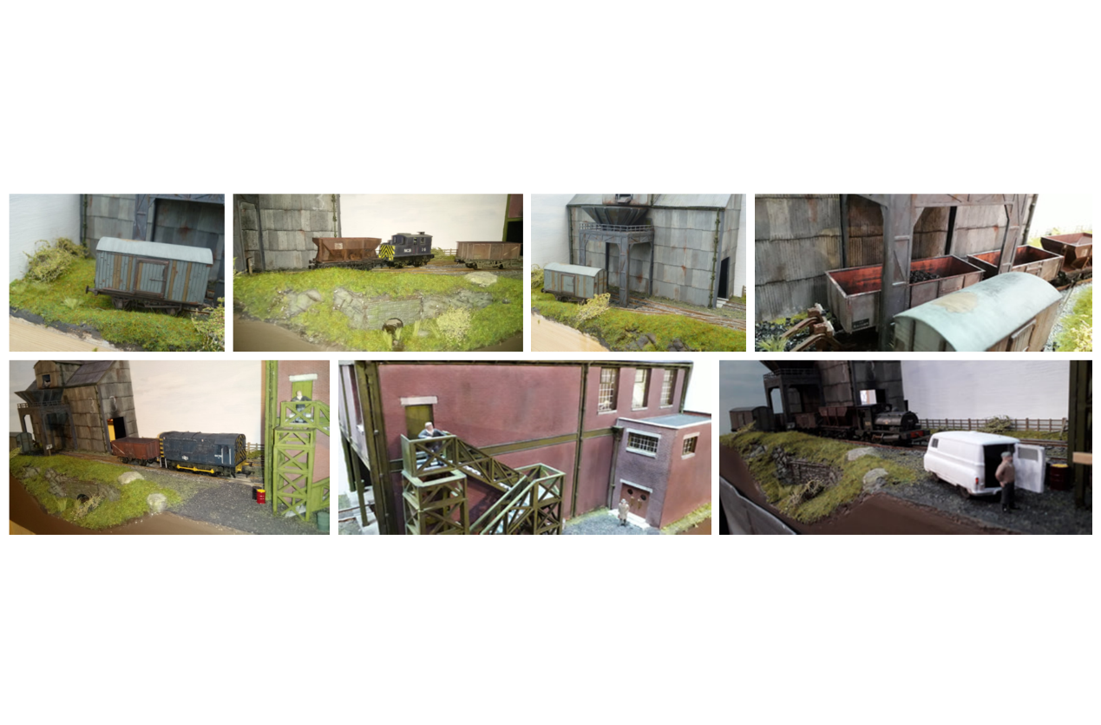
Jacks Hill Loading Point 3 is a 4mm/OO gauge minimum space shunting puzzle, set in the coal industry 1950’s-1980’s

Please see below for exhibition requirements:

Layout size: | 3ft x 1ft
Operating area: | 6ft x 6ft
Operating height (trackbed): | TBC
Operators: | 2
Tables required: | 1
Chairs required: | 1
Power supply required: | 1 socket, 5 amps min
Insurance value – Layout: | £600
Insurance value – Stock: £ | £400
Transportation: | Private car

Please complete the details below and return by email

Exhibition:
Venue:
Dates:
Contact name:
Contact number:

Thank you for showing interest in my layout, if you have any questions, please email me

