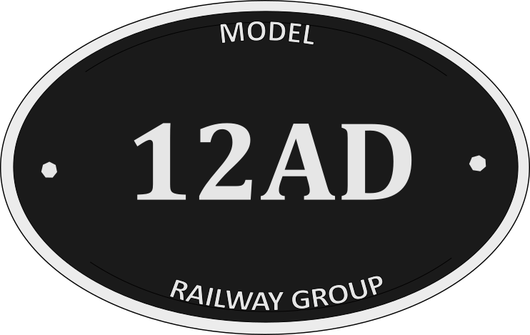

Eaglesham
By Bill Auld

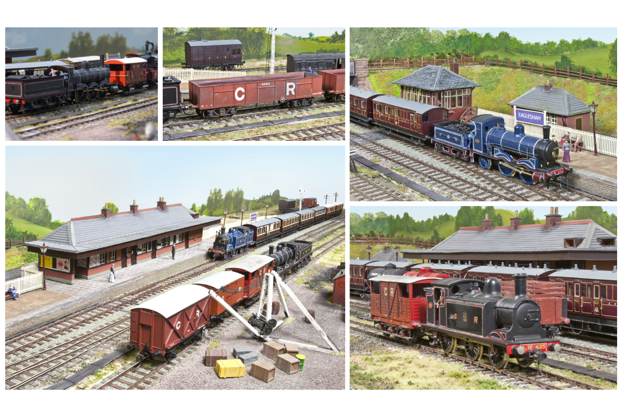

Eaglesham is a 4mm/OO gauge layout, DCC controlled, set to the south of Glasgow in 1912, featuring kit and scratchbuilt predominantly Caledonian Railway stock.

Please see exhibition requirements below:

Layout size: | 29ft x 3ft
Operating area: | 33ft x 7ft
Operating height (trackbed): | TBC
Operators: | 3-4*
Tables required: | 1
Chairs required: | 2
Power supply required: | 1 socket, 5 amps min
Insurance value – Layout: | £TBC
Insurance value – Stock: £ | £TBC
Transportation: | SWB Transit size van, plus private car**

* 4 operators required for exhibitions more than 100 miles from G75
**private car required with 4 operators

Please complete the details below and return by email

Exhibition:
Venue:
Dates:
Contact name:
Contact number:

Thank you for showing interest in my layout, if you have any questions, please email me

